Influencers:

Day 1: Email #1
Subject Line: Eliminate Repetitive Data Entry in Your Accounts Payable Workflow

Hi {{first_name}},

I hope this message finds you well. I'm Tyler, a member of the Square 9 team dedicated to empowering success in Accounts Payable departments.

We understand that paper-based work is a soul-crushing, profit-sapping drag on individual, team, and company productivity. That’s why we developed an AI-powered intelligent document processing platform designed to take the paper out of your work and make it easier to get things done with digital workflows.

Ready to ditch manual data entry for good? Watch this 2-minute video to see how you can let AI do the heavy lifting, freeing you to focus on what truly matters.

Best,

Day 3: Email #2
Subject Line: Say goodbye to tedious data entry!

Hi {{first_name}},

There’s a new world of automation out there for Accounts Payable departments, which means finally taking the paper out of work and letting artificial intelligence do the heavy lifting.

Want to learn more? Square 9 has all the info you need in our expert guide, Your Ultimate Guide to Accounts Payable Automation.

This new guide lays out exactly how AI can help you end lost or misplaced invoices, approval bottlenecks, and the tedious process of data entry into all of your different systems.

Here’s a sneak peek into what AI can do: AI can capture and extract key data from your docs, access information in the office or from home, streamline your three-way matching process, and automate invoice approval routing.

Best,

Day 5: Email #3
Subject Line: Experience the Power of AI in Accounts Payable: Try it Out for Free

Hi {{first_name}},

It's time to end repetitive keystrokes, restricted flow of information, and time-consuming processes that affect the efficiency of your Accounts Payable department

Our cutting-edge solution, TransformAI, automatically captures all essential data from documents by discerning the identity and location of information on each page without template-based extraction. By accurately extracting information at this level, you can confidently replace tedious manual work and embrace increased productivity at a fraction of the traditional costs.

Try it out now with up to 5 invoices for free.

Best,

Day 8: Email #4
Subject Line: Is Your Accounts Payable Department Overwhelmed?

Hi {{first_name}},

Want to learn how you can lower costs and increase efficiency through AP automation?

Square 9’s AI-powered capture automation is the Accounts Payable solution designed to deliver full document workflow capabilities. From document capture to data extraction and intelligent data recognition.

Witness the power for yourself in this On-Demand Webinar and find out how you can take advantage of AI-assisted capture.

Best,

Day 11: Breakup Email
Subject Line: Final opportunity: Accounts Payable follow up

{{first_name}},

I hope this email finds you well. I am reaching out one last time regarding accounts payable automation.

Considering the potential impact on your bottom line, I'd like to ask you directly: Is there any specific reason why you haven't moved forward with exploring accounts payable automation? Your feedback will help me understand your current priorities better and determine if there's anything more we can do to assist you.

I look forward to hearing from you soon.

Best,

Decision Makers:

Day 1: Email #1
Subject Line: Eliminate Repetitive Data Entry in Your Accounts Payable Workflow

Hi {{first_name}},

Manual errors, delays, and inefficiencies in managing accounts payables can hinder your company's growth and profitability. Don’t let {{company}} operate at a competitive disadvantage by wasting time on an inefficient accounting process. Processing paper documents is slow and costly; let us show you how we can eliminate paper from your workflow.

With our solutions, you can streamline your accounts payable process, reduce errors, and free up valuable time for your team to focus on value-creating tasks.

Ready to ditch manual data entry for good? Watch this 2-minute video to see how you can let AI do the heavy lifting, freeing your team to focus on what truly matters.

Best,

Day 3: Email #2
Subject Line: See How {{company}} Can Save by Eliminating Paper

{{first_name}},

Want to learn how you can lower costs and increase efficiency through Accounts Payable automation?

Our AI-powered document capture software revolutionizes accounts payable processes by automating invoice data extraction. With advanced artificial intelligence, it accurately captures all essential information from vendor info to line item extraction, reducing errors and saving time.

Customizable to your needs, our user-friendly solution ensures a smooth transition and ongoing support. Experience the future of invoice data extraction to increase productivity and eliminate unnecessary costs.

Discover the future of your accounting department in just one minute. Click to watch our 1-minute video introduction to start your journey to unparalleled efficiency with Square 9.

Best,

Day 5: Email #3
Subject Line:

Hi {{first_name}},

It's time to end repetitive keystrokes, restricted flow of information, and time-consuming processes that affect the efficiency of your Accounts Payable department

Discover how we transformed the daily operations at Cato Gas & Oil, as described by their IT Director: "Clerks spend more time doing reconciliation instead of filing. KeyFree Indexing has helped the Accounting department streamline the archiving of invoices and daily paperwork. Gathering all necessary information can be done within a matter of seconds."

Read More to see how easy it was for Cato Gas & Oil to save with Square 9.

Best,

Day 8: Email #4
Subject Line: Why Square 9? Explore the Latest Rave Reviews

Hi {{first_name}},

I hope this message finds you well. At Square 9, we believe in letting the results speak for themselves. We're thrilled to share with you a snapshot of the recognition we've earned from review sites for 2023.

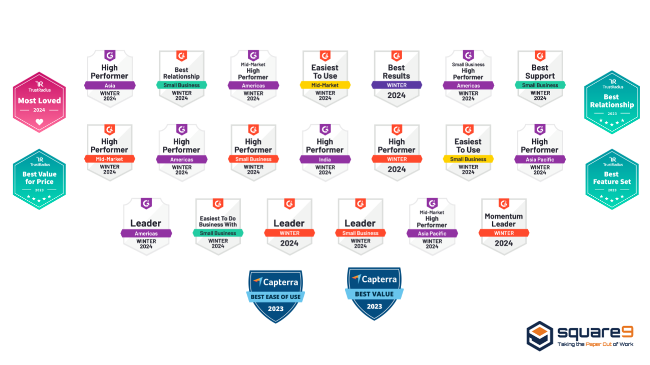

One of our customers said it best: “Square 9 is a solid software company from the CEO on down. Their dedication to customer satisfaction is only surpassed by their constant desire to improve their products.”

Curious about the experiences of other users? Dive into our other G2 Reviews to see why Square 9 has a 96% client retention rate year-over-year.

Best,

Day 11: Breakup Email
Subject Line: Final opportunity: Accounts Payable follow up

{{first_name}},

I hope this email finds you well. I am reaching out one last time regarding accounts payable automation.

Considering the potential impact on your bottom line, I'd like to ask you directly: Is there any specific reason why you haven't moved forward with exploring accounts payable automation? Your feedback will help me understand your current priorities better and determine if there's anything more we can do to assist you.

I look forward to hearing from you soon.

Best,

